MAWLANA BHASHANI SCIENCE AND TECHNOLOGY UNIVERSITY
SANTOSH, TANGAIL-1902



DEPARTMENT OF INFORMATION AND COMMUNICATION TECHNOLOGY
Lab Report

Lab Report No : 03
Lab Report on : Study of Z-transform, inverse Z-transform, and residue method using
MATLAB.
Course Title : Digital Signal Processing Lab
Course Code : ICT-3206
Submitted By | Submitted To
Name: Kuldip Saha Mugdha  ID: IT-22018  3rd Year, 2nd Semester  Session: 2021-2022  Dept. of ICT, MBSTU | Dr. Mst. Nargis Akter  Professor  DEPARTMENT OF INFORMATION AND COMMUNICATION TECHNOLOGY  MAWLANA BHASHANI SCIENCE AND TECHNOLOGY UNIVERSITY

Date of Performance: 16/11/25 Date of Submission: 23/11/25
Introduction:
The Z-transform is an important tool in Digital Signal Processing for analyzing discrete-time signals and systems. It converts time-domain sequences into the complex frequency domain, making system analysis easier. Inverse Z-transform is used to recover the original signal. Residue and polynomial division methods are commonly used techniques to find inverse Z-transforms. This experiment demonstrates these concepts using MATLAB.

Objective:
- To find the Z-transform and inverse Z-transform of discrete-time signals.
- To determine residues of a rational Z-transform function.
- To obtain inverse Z-transform using the polynomial division method.

Theory:
The Z-transform of a discrete-time signal $x(n)$is defined as
$$X(z)=\sum_{n=-∞}^{∞}{x(n)}z^{-n}$$
The inverse Z-transform converts $X(z)$back into $x(n)$.
The residue method is used to express a rational Z-transform as a sum of partial fractions.
The polynomial division method expands the Z-transform into a power series to obtain the time-domain sequence.

MATLAB Code:

Program 1: Z-transform and Inverse Z-transform

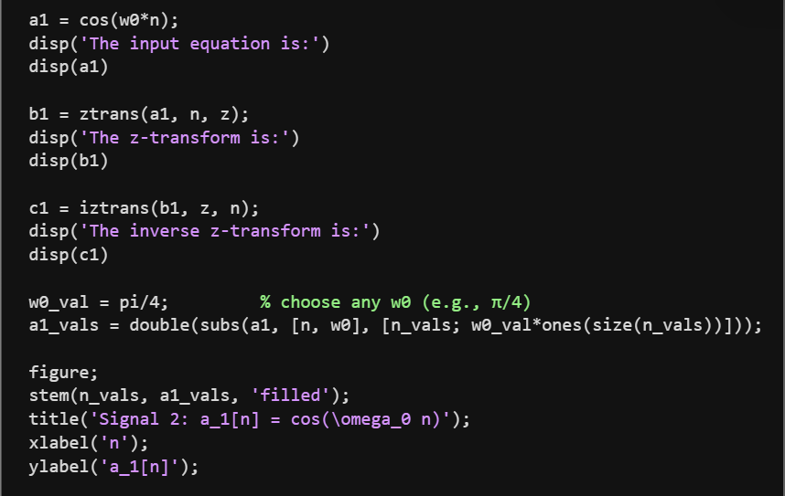
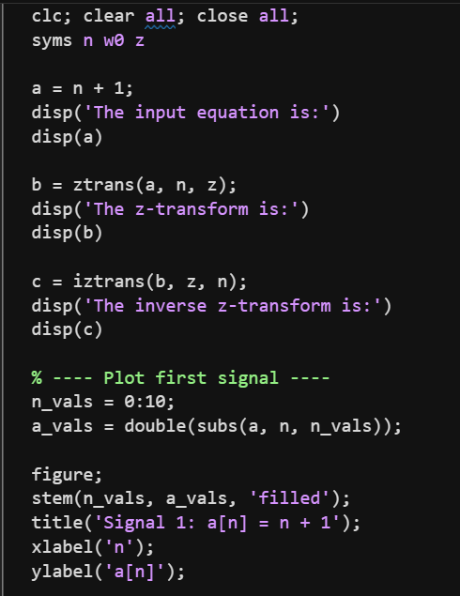

Output:
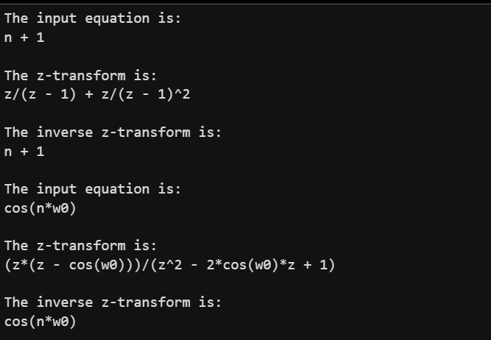
Program 2: Residue Calculation
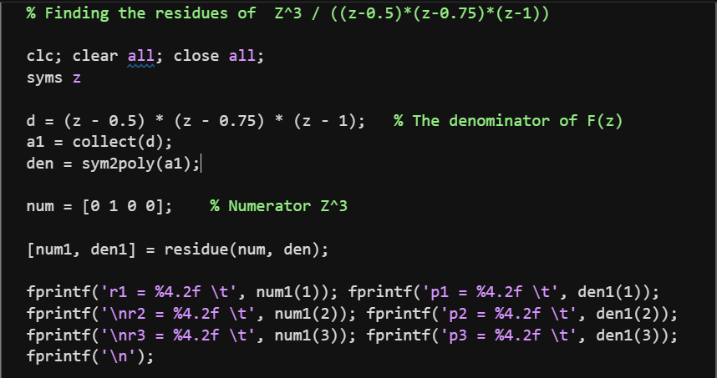
Output:
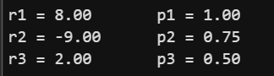
Program 3: Inverse Z-transform Using Polynomial Division
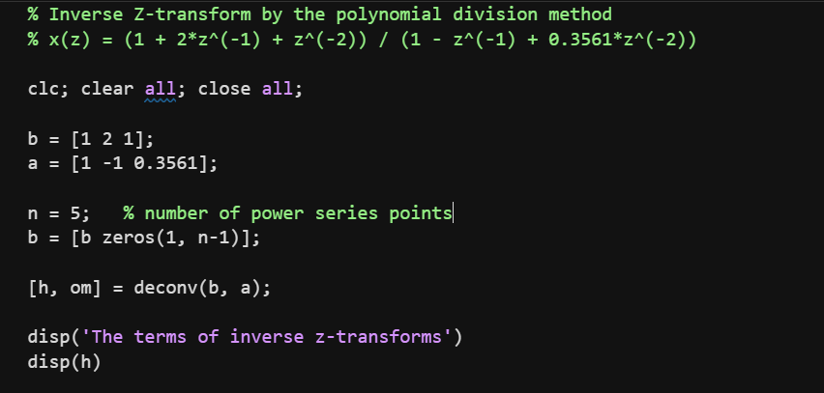
Output:

Result:
- Z-transform and inverse Z-transform of given signals were obtained successfully.
- Residues and poles of the given Z-domain function were calculated correctly.
- Inverse Z-transform using polynomial division was successfully determined.

Conclusion:
This experiment demonstrated the application of Z-transform and inverse Z-transform techniques using MATLAB. Residue and polynomial division methods were effectively used to analyze discrete-time systems.

